BNC Welfare Support 2023-24: Where, Who, and When?
Help in an emergency
Immediate medical attention – examples:
Serious physical injury or accident? Somebody very ill? Suicide attempt or serious self-harm? Mental health crisis (hearing voices, hallucinating, totally lost control of situation)?
Call Porter’s Lodge for First Aider
01865 277 830

Call 999 – for ambulance.
Porters will raise a Junior Dean to offer assistance.
Immediate help with safety - examples:
Are you or is someone you know feeling unsafe? Is there a fire?
Are you witnessing some dangerous behaviour?
Have you experienced yourself or witnessed another person receiving unwelcome sexual attention of any kind? Please see the College Sexual Violence and Harassment Response Flowchart on the next page, and for more information go to:
https://www.ox.ac.uk/students/welfare/supportservice

Help during evenings, weekends or in the vac
Is it the weekend or an evening during term time and it can’t wait until daytime Mon-Friday 9am-6pm? During evenings and at weekends contact a Junior Dean via the porter’s lodge. (On a Sunday the Chaplain is also available). A Peer Supporter or Welfare Rep might be able to see you during the day or on a weekend. Is it in the vacation Mon-Fri 9am-6pm? choose a green box from page 3 of this leaflet. If it is out of these hours in the vacation and it can’t wait until Mon-Fri 9am – 6pm phone the porter’s lodge 01865 277830 for further assistance.
Call Porter’s Lodge for security - 01865 277 830
Call 999 – police (or fire brigade in case of fire)
Call University Security Services emergency line – 01865 289999

Call Porter’s Lodge
01865 277 830
Call 999 – police or contact Sub Dean via porter’s lodge if you do not wish to contact the police.

Victim of or witness to a crime?
Have you experienced or witnessed a criminal offence?

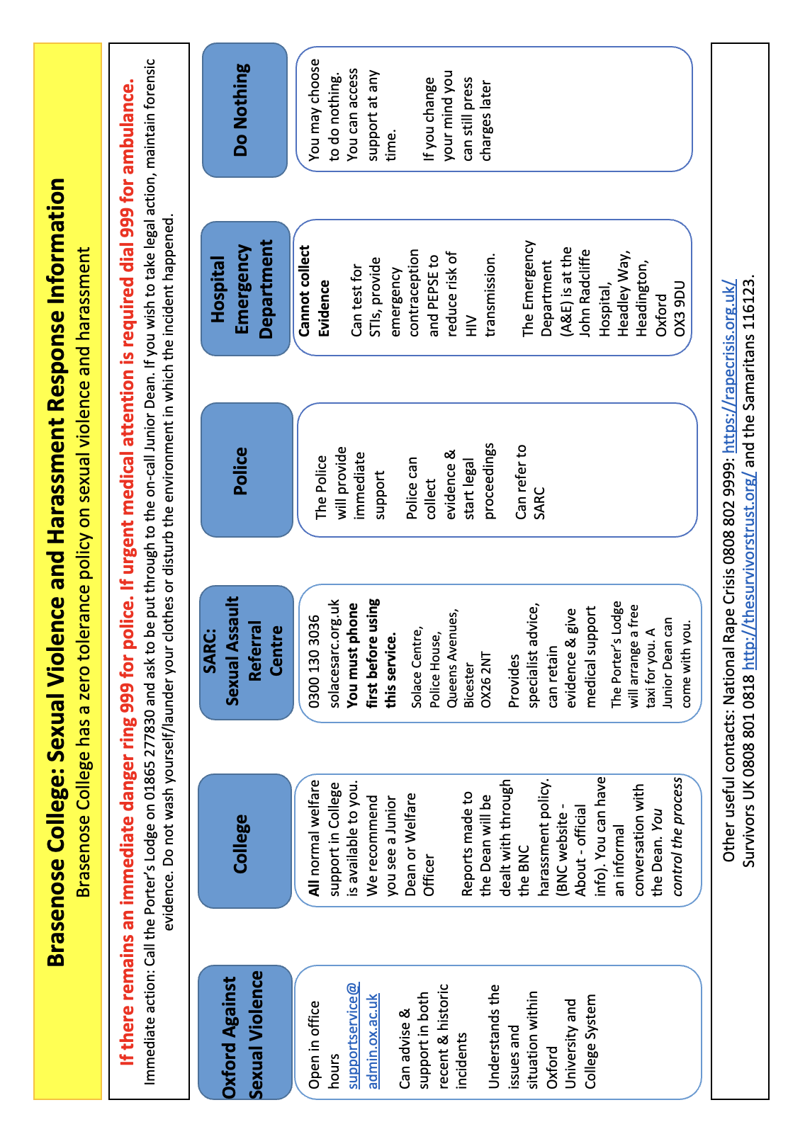
Issues big or small when it’s not an emergency
it can really help to talk things over
SPIRITUAL & RELIGIOUS SUPPORT Do you want to be linked in with your own faith community or discuss spiritual issues? Contact the Chaplain chaplain@bnc.ox.ac.uk
FINANCIAL SUPPORT Are you having financial worries? See Finance Bursary in St Mary’s (near the JCR) or email college.accountant@bnc.ox.ac.uk
HEALTHCARE and FIRST AID Is it a medical problem that does not need immediate attention? See a College Doctor at Jericho Health - 01865 311234 (term time or vacation) or the College Nurse (weeks 0-9) ASAP college.nurse@bnc.ox.ac.uk /phone her via the lodge. Is one of your friends in need of help? Call Porter’s Lodge for Junior Dean help (in term) 01865277830
MENTAL HEALTH OR EMOTIONAL SUPPORT Would you like to talk to someone who isn’t one of Brasenose or University staff? Please speak to a friendly Peer Supporter, Welfare Rep or Junior Dean in term time. Need confidential listening or signposting to other forms of support? Contact Chaplain or Sub Dean. Want to explore counselling options? Contact our Student Support Adviser, Dr Sebastian Petzolt: studentsupport@bnc.ox.ac.uk, your GP or the Oxford University Counselling Service: counselling@admin.ox.ac.uk

ANTISOCIAL BEHAVIOUR Have you or someone you know experienced discrimination, hatred, bullying, harassment? Contact one of our college harassment officers: the Dean, Sub Dean, Chaplain, Senior Tutor, Dr Anne Edwards. If you would like to speak to someone outside of college or someone who identifies as LGBT phone: 01865 270760 or email harassment.line@admin.ox.ac.uk or see: https://edu.admin.ox.ac.uk/support#collapse1231811

Is someone making a lot of noise after hours? Call 24/7 Porter’s Lodge for a Junior Dean to restore quiet hours in term or a porter to do so in vacation.
ACADEMIC SUPPORT Are you struggling with your academic work or deadlines? Contact your Tutor, the Senior Tutor, the Chaplain, or the Sub Dean in or out of term.
Are you struggling with academic writing? In term time contact our writing fellow, Kirsty Gunn: kirsty.gunn@rlfeducation.org.uk orour Study Skills Mentors: study.skills@bnc.ox.ac.uk
DISABILITY SUPPORT Need academic support or exam adjustments? Email the College Office: college.office@bnc.ox.ac.uk. Have questions regarding accommodation or food provision? Email the Domestic Bursar: domestic.bursar@bnc.ox.ac.uk

Student Handbook (Blue book) College Policies

Useful College Welfare Contacts
In an emergency, call the emergency services (police/fire/ambulance on 999)
and update the lodge (01865 277 830).

The College GP surgery, the Jericho Health Centre, can provide non-emergency medical help and advice, including for mental health issues: 01865 311 234. Also, NHS 111 can be called for non-urgent medical advice, dial 111.

The Dean, Professor Simon Shogry, is the lead of all student welfare in college. He can be reached at dean@bnc.ox.ac.uk or phoned via the lodge.

The Sub-Dean, Dr Arnaud Petit, offers confidential listening and support to students. With the dean, he also oversees the work of the junior deans. His office is in XVIII-5 and he can be reached at subdean@bnc.ox.ac.uk or phoned via the lodge.

The College Chaplain, Revd David Sheen, offers support and confidential listening about any issue and signposting to many other sources of welfare support. The Chaplain’s office is in Heberden 1 (above the JCR). Contact him by email chaplain@bnc.ox.ac.uk or phone 01865 277833 or via the lodge.

The College Nurse, Kinneret Milgrom, has an office at the bottom of staircase 12 and holds weekday surgeries with online and in-person slots. The nurse is available in weeks 0-9.  Email:college.nurse@bnc.ox.ac.uk or contact via the lodge. To book an appointment: https://www.bnc.ox.ac.uk/collegenurse | The Student Counsellor, Dr Sebastian Petzolt, offers confidential counselling, wellbeing, and emotional support. The counsellor is available in weeks 0-10.  Email: studentsupport@bnc.ox.ac.uk.  To book a session visit: http://www.bnc.ox.ac.uk/collegecounsellor
The Junior Deans can be contacted at junior.dean@bnc.ox.ac.uk, or via the lodge.

The Diversity and Equality and Harassment Officer is Dr Anne Edwards.
Email: anne.edwards@bnc.ox.ac.uk

The Senior Tutor, Dr Simon Smith, can be emailed at senior.tutor@bnc.ox.ac.uk and Graduates can contact the Tutor for Graduates – Professor Eamonn Gaffney by email: gaffney@maths.ox.ac.uk

Oxford University Counselling Service sees students experiencing emotional and psychological problems: https://www.ox.ac.uk/students/welfare/counselling
Please email counselling@admin.ox.ac.uk (This is NOT an emergency service. Contact the Lodge in a crisis.) The Samaritans provide confidential emotional support, 24/7: 116123 (free) and Oxford Nightline is a confidential listening service, run by students for students, 8pm-8am during term time: 01865 270 270 (free).

HCR Welfare Reps (who are also Peer Supporters)  (including Diversity & Equality Rep and Women’s Officers) | JCR Welfare Reps & Peer Supporters (as well as Rainbow Peers & Peers of Colour)

