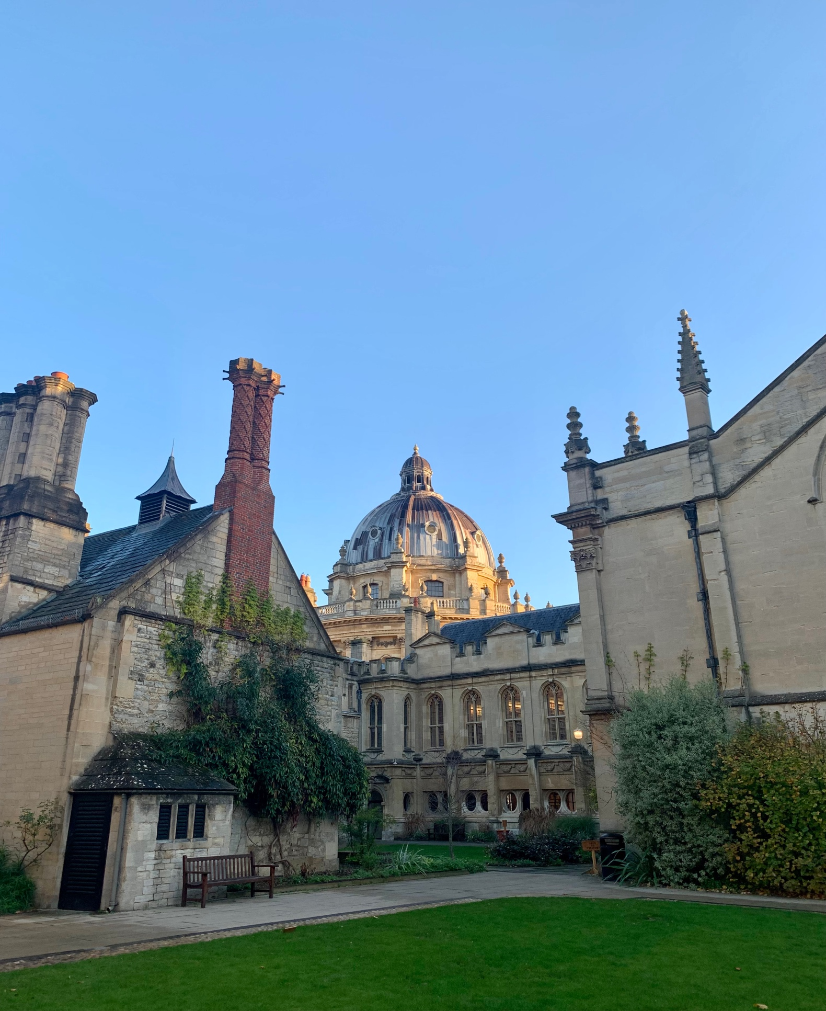

**Brasenose College Chapel**

**Michaelmas Term Card 2023**

**A warm welcome!**

**All members of college regardless of Christian denomination, or faith, or no faith, are very welcome to attend services & events in chapel.**

**Regular Midweek Services**

*in chapel weeks 1-8 unless otherwise stated*

|  |  |  |  |  |
| --- | --- | --- | --- | --- |
| **Monday** | **Tuesday** | **Wednesday** | **Thursday** | **Friday** |
| 8.10-8.30am  Morning Prayer | 8.10-8.30am  Morning Prayer | 9.10-9.30am  Morning Prayer | 8.10-8.30am  Morning Prayer | 8.10-8.30am  Morning Prayer |
| 12.30pm-1.00pm  Silent Stillness | 12.30pm-1.00pm  Silent Stillness | 12.00-12.15pm  Non-religious Guided Meditation  12.30pm-1.00pm  Silent Stillness | 12.30pm-1.00pm  Silent Stillness | 12.30pm-1.00pm  Silent Stillness |
|  | 6.00-6.45pm  The College Eucharist  *A service of Holy Communion with organ music and hymns. With drinks & nibbles afterwards.*  *In* ***week 7*** *we host the RC College Mass at 6.00pm, served by the Catholic Chaplaincy.* |  | 5.30pm Christian Union *meeting in Heberden 1* | 6.00pm Concert *in the antechapel.*  *See BNC Music website for details.* |
|  | 9.30pm  Compline *- a short student led candlelit sung service of Night Prayer.* | 7.00pm  Choir Rehearsal |  |

**The Holy Eucharist** (Holy Communion, the Lord’s Supper, or Mass) is celebrated on **Sundays** and **Tuesdays** in term. If you are baptised and usually receive communion, you are welcome to do so here. Otherwise, you can receive a blessing.

**Silent Stillness -** these are times when chapel will be guaranteed to be completely quiet so any member of college can come and enjoy the space to be still, meditate, pray, read, or just sit quietly and enjoy the silence.

**Special Services, Events, & Notices**

**Wk 1 Tues 10th Oct. Chapel Freshers & Returners pub meal, 6.45pm** after the Tuesday evening Eucharist, meet in the antechapel. A free drink & pub meal.

**Wk 3 Fri 27th Oct. Platnauer Concert 6.00pm – 7.00pm** in the antechapel followed by drinks in Mediaeval Kitchen. Free admission to all from Brasenose.

**Wk 4 Tues 31st Oct. 6.00pm Sung Eucharist for All Souls** *in chapel*.

**Wk 5 Fri 10th Nov. An Act of Remembrance,** 10.55am -11.05am *in the antechapel.*

**Wk 7 Tues 21st Nov. Roman Catholic College Mass** at 6pm, served by the Catholic Chaplaincy. Drinks & nibbles served following the service.

**Wk 7 Fri 24th Nov. Oxmas *Nearly* Midnight Mass, 10.00pm - 11.00pm** *in chapel*.

**There will an *Interfaith* meal & talk** in term, details are to follow.

**A relaxed Friday walk, often with my dog,** 3.00pm, open to all, followed by tea & cake.

Meet at the Lodge.*Weeks 1 to 6.*

**Do you want to explore the Christian faith, to be baptised, or confirmed?**

*Please speak to the Chaplain.*

**Sunday Mornings in Chapel**

**9.00am** **Holy Eucharist** Celebrant & Preacher: The Chaplain.

**9.40am** **Chaplain’s Breakfast** in Heberden 1.

***It’s free and all are welcome***. With decent tea & coffee, fresh fruit, & pastries.

**3.45pm** **Choir Tea** in III/8 - Open to all members of the choir & chapel community and hosted by the Bible Clerk.

**Sunday Evenings in Chapel**

**6.00pm College Prayers**

*College Prayers is usually a service of Choral Evensong, a sung service with the chapel choir, organ music, congregational hymns, and a talk by the chaplain or a visiting speaker, followed by drinks in the Amersi room, & dinner.*

**Week 1** *Welcome Service*

8th October **The Chaplain**

**Week 2** *19th Sunday of Trinity*

15th October **The Revd Hannah Cartwright,** Assistant Priest of the University Church of St Mary the Virgin, Oxford.

**Week 3** *20th Sunday of Trinity*

22nd October **The Chaplain**

**Week 4** *Last Sunday of Trinity*

29th October **The Revd Jesse Smith,**Parish Priest & Community Organiser.

**Week 5** *Sung Eucharist for All Saints’ Sunday.*

5th November **The Revd Canon Dr Mark Clavier,** Canon Theologian & bishop’s chaplain,author, & sometime vice-principal of St Stephen’s House, Oxford.

**Week 6** *Remembrance Sunday*

12th November **The Chaplain**

**Week 7** *2nd Sunday before Advent*

19th November **The Revd Liz Griffiths** Director of Training at Bridge Builders Ministries who focus on mediation, conflict resolution, & transforming church culture. A passionate advocate of peace and justice.

**Week 8** *Carol Service*

26th November **The Chaplain**

**The College Chapel** is a space for all members of college, their families, and friends. It is a sacred space set aside for contemplation, prayer, and worship. A place to find peace or simply be and enjoy some quiet and its beauty. We aim to be friendly & welcoming community and we invite you to cross the threshold and be at home in chapel. It is also a place used for music making and practice. We always welcome volunteers to read, speak, serve & intercede, so if you’d like to participate, please speak with the Bible Clerk or the Chaplain.

**People**

**Director of Music**: Polina Sosnina

**Organ Scholars**: Sean Cohen and Emma van Setten

**Chapel Choir:** All members of Brasenose are welcome to sing in the famously fun and friendly Chapel Choir, led by our Director of Music, Polina Sosnina (XII.13; [musicdirector@bnc.ox.ac.uk](mailto:musicdirector@bnc.ox.ac.uk)) and our organ scholars.

**Bible Clerk:** James Hartley [james.hartley@bnc.ox.ac.uk](mailto:james.hartley@bnc.ox.ac.uk)

**Assistant Bible Clerk:** Nishen Menerapitiyage Don

**HCR Chapel Rep:**  *vacant – if interested please speak with the chaplain.*

**Roman Catholic Rep:** Nishen Menerapitiyage Don

<https://www.catholic-chaplaincy.org.uk/>

**Christian Union Rep:** Alex Massie [alex.massie@bnc.ox.ac.uk](mailto:alex.massie@bnc.ox.ac.uk) and on Facebook: Brasenose and Lincoln College Christian Union.

**Collegiate University Chaplains & Faith Groups, information & contacts:**

<https://www.ox.ac.uk/students/welfare/chaplaincy>

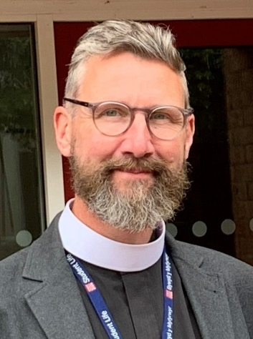

**College Chaplain:** The Revd David Sheen

I am an Anglican priest and I’m **available to all members of college** as a listening ear & a support in things both small & great. I am a key member of the Welfare Team, extending pastoral care to all members of college, **of all faiths & none**. Please don’t hesitate to email me if you want to talk something over. I can be found in Heberden 1 (above the JCR on the first floor).

Email [chaplain@bnc.ox.ac.uk](mailto:chaplain@bnc.ox.ac.uk) or telephone: 01865 277833.

In an emergency David can be contacted via the Lodge. Should you need to speak to the chaplain in an accessible room then he is happy to arrange this.

**Our Chapel Charity: *This term we are supporting* *Christian Aid - an inspiring charity working with all faiths and none globally. It partners with local agencies to work on vital projects - to make life better for people and help them lift themselves out of extreme poverty or cope with life after a natural disaster. We take a collection during College Prayers, and you can also use the use the Tap n’ donate contactless machine in the Antechapel. More information on Christian Aid can be found here:*** [**www.christianaid.org.uk**](http://www.christianaid.org.uk)



**Student led Facebook groups:**

Brasenose Chapel Choir, email: [sean.cohen@bnc.ox.ac.uk](mailto:sean.cohen@bnc.ox.ac.uk) to join.

Christianity in Brasenose 23/24, email: [james.hartley@bnc.ox.ac.uk](mailto:james.hartley@bnc.ox.ac.uk) to join.

**Brasenose Hilary**

**College Chapel Term 2022**